The Wet Koala

Miscellaneous Interesting Facts

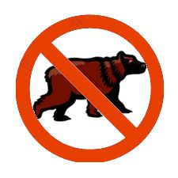

Many People Believe Koalas are Bears But in fact they are Marsupials

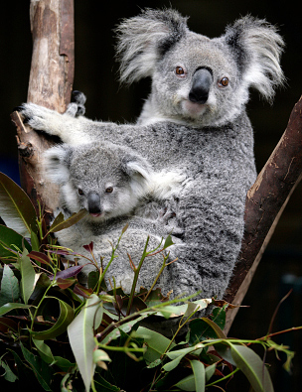

It’s a common misconception that Koalas are drunk on Eucalyptus. They are actually just sleeping to recover from the strains of digesting Koalas

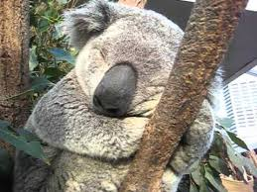

Koalas actually Sleep for 22 hours a day on average